Le numérique dans l’art. Pierre Berger.
Video . VR
La réalité virtuelle. Labsurd
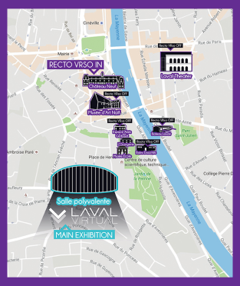 http://diccan.com/Blog5/RectoVr_So_1.html
http://diccan.com/Blog5/RectoVr_So_2.html
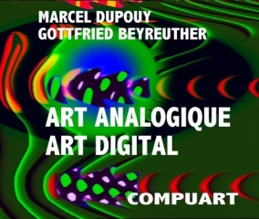 http://diccan.com/Blog7/Dupouy_2018.html
http://diccan.com/History/History_2010.html#Video
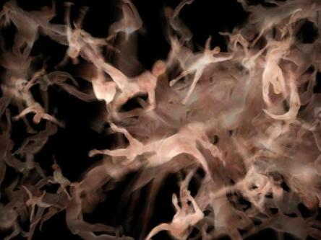 http://diccan.com/Blog/Hentschlager.htm https://www.youtube.com/watch?v=keer3JMxEPU
http://diccan.com/Elog/Absolute.html
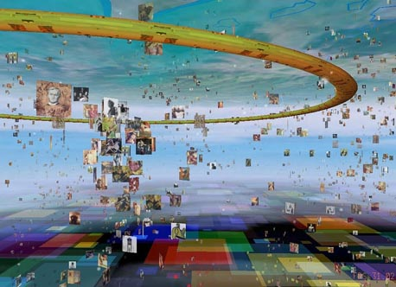 http://diccan.com/Elog/Auber_Worms.html
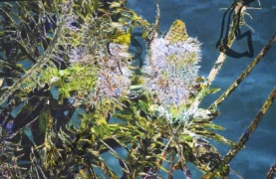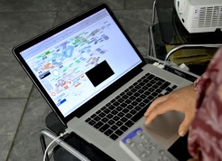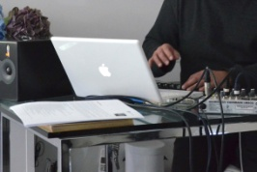
http://diccan.com/Blog/Perconte_2013.html
http://diccan.com/Blog/Perconte2.html Successive impressions
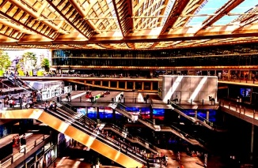 http://diccan.com/Blog3/Chevalier_2017_2.html
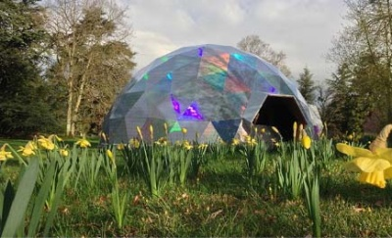 http://diccan.com/Blog3/Chevalier_2017_1.html Generative gardens
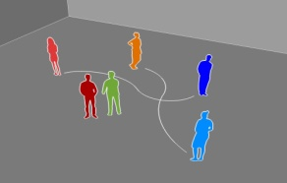 http://diccan.com/Blog4/Schmitt_2017.html
file:///F:/!!!SITE_WEB/Elog/Schmitt_Absolute.html
http://diccan.com/Blog7/Openings.html

